



Abstract
Historica is a browser-based immersive platform that leverages AR and 3D modeling to digitally recreate historical sites as they appeared in ancient times. Traditional history education often relies on static images and text, which limits student engagement and fails to convey the true scale and grandeur of past civilizations. Historica addresses this gap by offering interactive 3D reconstructions that can be explored directly through any modern web browser. By bridging technology and the humanities, the platform transforms passive learning into an active, exploratory experience and ensures the accessibility of history to a wider audience.
- Gather historical data, architectural blueprints, and visual references from authentic sources such as UNESCO, CyArk, and heritage archives.

- Optimize models for web and AR compatibility (lightweight, low-poly without compromising detail).

- Add informative annotations, text descriptions, and historical context to each model for enhanced educational value.

- Build a responsive, intuitive interface u with smooth navigation and user experience.

- Optimize models to ensure quick loading and real-time interaction on web platforms.

- Enable scalability and support for future expansion (adding more historical sites or languages).

- Regularly update the content and add new historical sites based on user interest and historical relevance.

Methodology

Historica: AR/VR Powered Immersive Learning Experience

Atharv Sharma (0827IT233D02), Khushi Agrawal(0827IT221076), Abhishek Rathore(0827IT233D01), Jatin Rao(0827IT233D03)
Dept. Of Information Technology , Acropolis Institute of Technology & Research, Indore
Session: Jan. – Jun. 2026

Results
- Historical sites were accurately reconstructed using 3D modeling tools like Blender and Maya.

- Developed an intuitive and responsive interface compatible with desktops, tablets, and smartphones for smooth navigation.

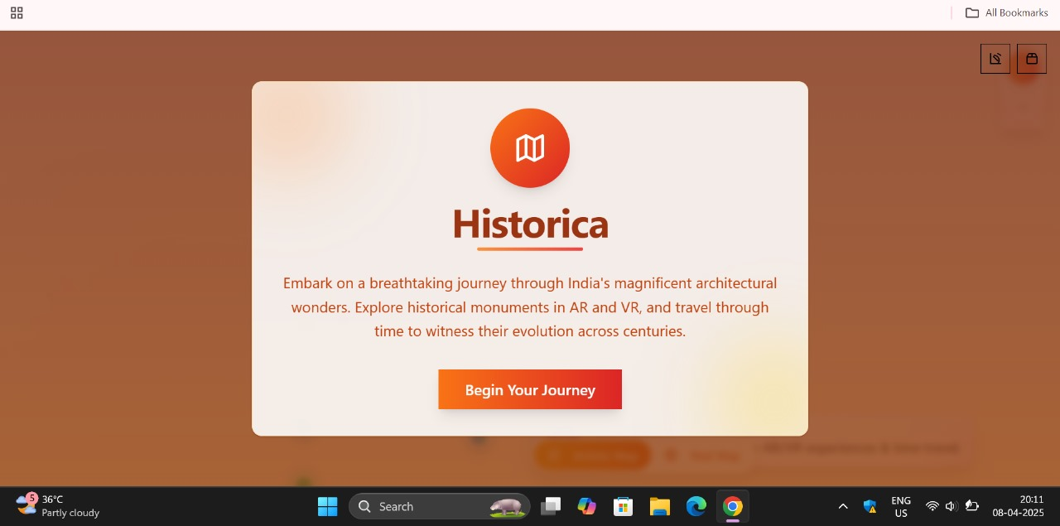

Introduction
- Historica is a web-based platform that allows users to explore interactive 3D reconstructions of historical monuments as they existed in ancient times.

- It addresses the growing need for digital heritage preservation and supports virtual education and cultural understanding.

- The platform aims to make historical learning more engaging, immersive, and accessible to students, educators, researchers, and history enthusiasts.

- Users can rotate, zoom, and interact with 3D models, accompanied by annotations and multimedia to enhance historical context.

- Historica bridges the gap between history and technology, turning passive reading into active exploration.

- and easy to access.
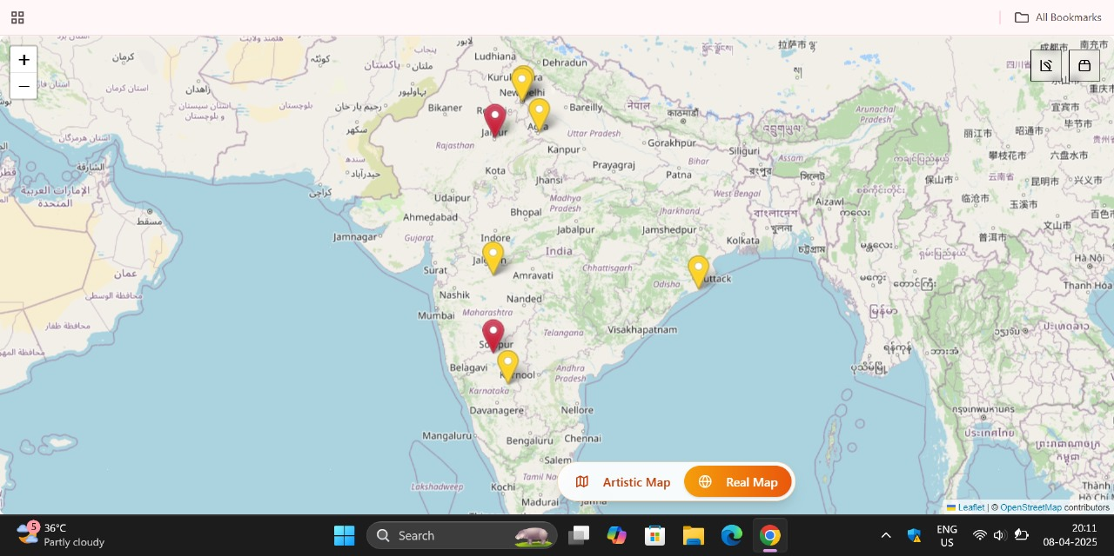

Conclusion
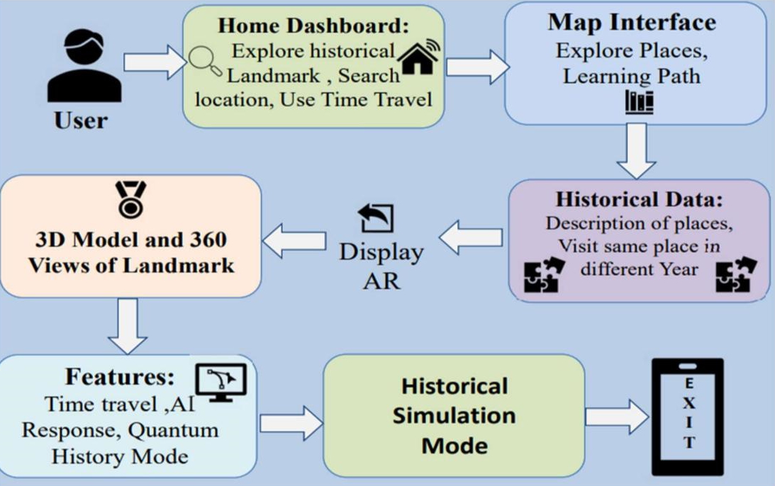
- Historica successfully combines technology and education to create an engaging platform for historical learning.

- Historica is scalable and adaptable, ready to expand with more sites, languages, and interactive features in future updates.

- The project demonstrates how immersive technologies can transform passive learning into a dynamic and meaningful experience.

Objectives

- To digitally recreate historical monuments and landmarks with realistic, high-quality 3D models for better visual understanding.
- To design the platform for universal access across various devices (PCs, laptops, smartphones, tablets) using only a web browser.

Acknowledgement

We would like to thank Prof. Monika Choudhary, our Project Guide, for her valuable guidance and constant support throughout the development of this project. We are also grateful to Prof. Mahendra Verma, our Project Coordinator, for his encouragement and timely assistance. Our sincere thanks to Prof. Prashant Lakkadwala (HOD) for giving us the opportunity and resources to work on this project.

